***Catalyst optimizer – Role of Logical and Physical Planning in Dataframes/Spark SQL***

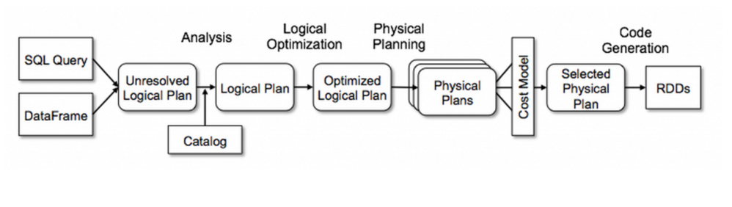

***What happens behind the scenes***

Moment a query is written , internally catalyst optimizer takes the query and runs through series of steps

* Analysis – Analyses the plain query itself , looks to see if the columns are valid etc. ( Based on a rule book )
* Logical planning and optimization – Logically evaluates and modifies . Ex: casting the expressions, simplying boolean expressions etc . Also optimizes the expressions ex: if there are two filter conditions, it simplifies using AND condition etc.
* Physical planning - Generates multiple Physical plans as output

Based on the cost metrics, best physical plan is chosen

***Sample Execution Plan***

val input = sc.textFile("marketing_data.csv");

val dataDF = input.map(x=>x.replace("\"","").split(';')).map(y=>(y(0),y(1),y(2),y(3),y(4),y(5),y(6),y(7),y(8),y(9),y(10),y(11),y(12),y(13),y(14),y(15),y(16))).toDF("age", "job","marital","education","default","balance","housing","loan","contact","month","day_of_week","duration","campaign","pdays","previous","poutcome","subscribed");

scala> val newDataDF = dataDF.where(col("age") !== "age").explain(true);

**== Parsed Logical Plan ==**

'Filter NOT ('age = age)

+- Project [_1#0 AS age#17,_2#1 AS job#18,_3#2 AS marital#19,_4#3 AS education#20,_5#4 AS default#21,_6#5 AS balance#22,_7#6 AS housing#23,_8#7 AS loan#24,_9#8 AS contact#25,_10#9 AS month#26,_11#10 AS day_of_week#27,_12#11 AS duration#28,_13#12 AS campaign#29,_14#13 AS pdays#30,_15#14 AS previous#31,_16#15 AS poutcome#32,_17#16 AS subscribed#33]

+- LogicalRDD [_1#0,_2#1,_3#2,_4#3,_5#4,_6#5,_7#6,_8#7,_9#8,_10#9,_11#10,_12#11,_13#12,_14#13,_15#14,_16#15,_17#16], MapPartitionsRDD[4] at rddToDataFrameHolder at <console>:29

**== Analyzed Logical Plan ==**

age: string, job: string, marital: string, education: string, default: string, balance: string, housing: string, loan: string, contact: string, month: string, day_of_week: string, duration: string, campaign: string, pdays: string, previous: string, poutcome: string, subscribed: string

Filter NOT (age#17 = age)

+- Project [_1#0 AS age#17,_2#1 AS job#18,_3#2 AS marital#19,_4#3 AS education#20,_5#4 AS default#21,_6#5 AS balance#22,_7#6 AS housing#23,_8#7 AS loan#24,_9#8 AS contact#25,_10#9 AS month#26,_11#10 AS day_of_week#27,_12#11 AS duration#28,_13#12 AS campaign#29,_14#13 AS pdays#30,_15#14 AS previous#31,_16#15 AS poutcome#32,_17#16 AS subscribed#33]

+- LogicalRDD [_1#0,_2#1,_3#2,_4#3,_5#4,_6#5,_7#6,_8#7,_9#8,_10#9,_11#10,_12#11,_13#12,_14#13,_15#14,_16#15,_17#16], MapPartitionsRDD[4] at rddToDataFrameHolder at <console>:29

**== Optimized Logical Plan ==**

Project [_1#0 AS age#17,_2#1 AS job#18,_3#2 AS marital#19,_4#3 AS education#20,_5#4 AS default#21,_6#5 AS balance#22,_7#6 AS housing#23,_8#7 AS loan#24,_9#8 AS contact#25,_10#9 AS month#26,_11#10 AS day_of_week#27,_12#11 AS duration#28,_13#12 AS campaign#29,_14#13 AS pdays#30,_15#14 AS previous#31,_16#15 AS poutcome#32,_17#16 AS subscribed#33]

+- Filter NOT (_1#0 = age)

+- LogicalRDD [_1#0,_2#1,_3#2,_4#3,_5#4,_6#5,_7#6,_8#7,_9#8,_10#9,_11#10,_12#11,_13#12,_14#13,_15#14,_16#15,_17#16], MapPartitionsRDD[4] at rddToDataFrameHolder at <console>:29

**== Physical Plan ==**

Project [_1#0 AS age#17,_2#1 AS job#18,_3#2 AS marital#19,_4#3 AS education#20,_5#4 AS default#21,_6#5 AS balance#22,_7#6 AS housing#23,_8#7 AS loan#24,_9#8 AS contact#25,_10#9 AS month#26,_11#10 AS day_of_week#27,_12#11 AS duration#28,_13#12 AS campaign#29,_14#13 AS pdays#30,_15#14 AS previous#31,_16#15 AS poutcome#32,_17#16 AS subscribed#33]

+- Filter NOT (_1#0 = age)

+- Scan ExistingRDD[_1#0,_2#1,_3#2,_4#3,_5#4,_6#5,_7#6,_8#7,_9#8,_10#9,_11#10,_12#11,_13#12,_14#13,_15#14,_16#15,_17#16]

newDataDF: Unit = ()